How to set Wiegand
Wiegand interface support WG26 and WG34, for Door control board.
Warning: Most control board support WG26. But Haikong’s board only support WG34, such as DS-K2601, DS-K2604.

Chapter 1 Open the Readsoft and connect the reader
- Connect the reader into PC by RS232 or USB or RJ45, then Open ReaderSoft.exe
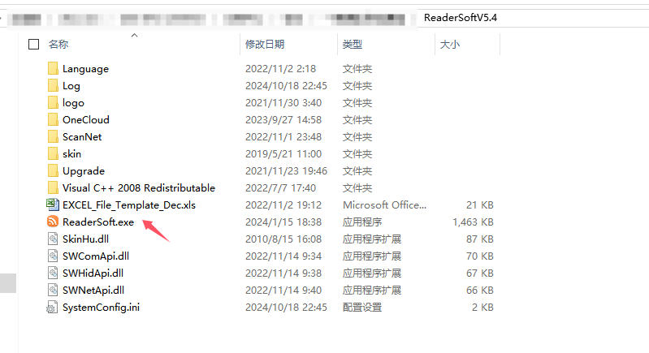
- At connection interface, choose the relevant port, for example, if your reader connect into PC by USB interface, then choose USB, if RJ45, then choose RJ45, etc. , then click open, then you can enter into the main interface

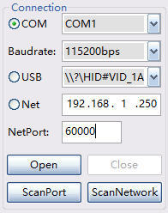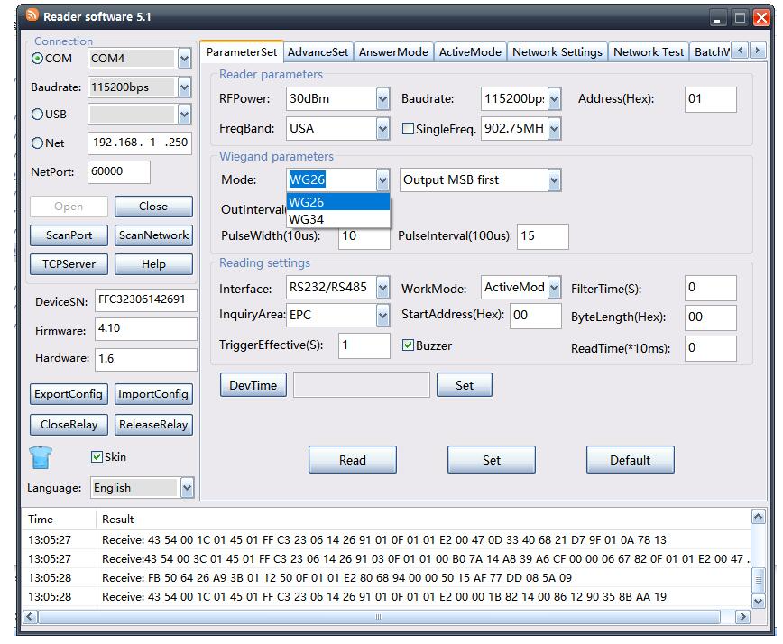
Chapter 2 Set Wiegand Output
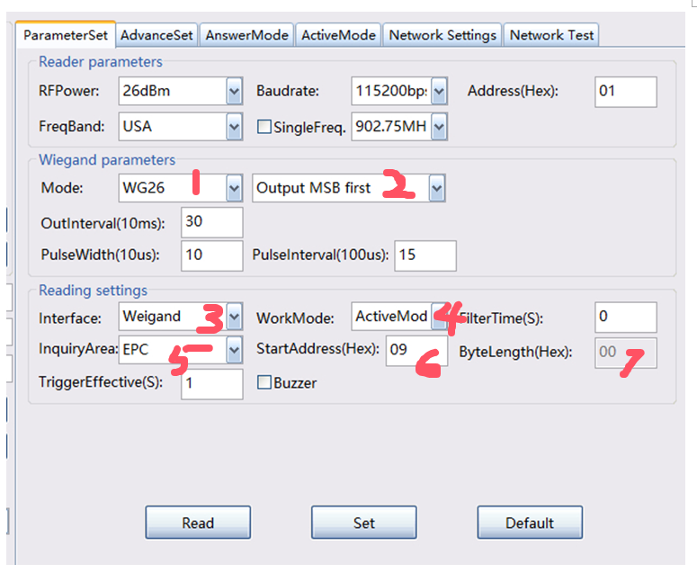

- Set Mode as WG26 or WG34
- Set Output MSB first or LSB first ( big endian, little endian)
- Set interface as Weigand
- Set work mode as ActiveMode
- Set inquiryArea as EPC or TID or other memory bank
- Set StartAddress and Bytelength. (For example a full EPC number has 24 HEX, while WG26 only fetch 6 HEX, WG34 only fetch 8 HEX, so you need to specify how to truncate it.)

Hereby, we listed the typical startaddress and bytelength setting for reading tag’s EPC
- For WG26, read Tag EPC last 3 bytes, then set StartAddress as 9. Bytelength is 3
- For WG34, read Tag EPC last 4 bytes, set StartAddress as 8. Bytelength is 4

After seting, click set button.

All Done.

